**Task 6**

**Task description:** Create Users and assign Roles to them in your preferred cloud.

* I did the task in AWS console.
* Go to IAM 🡪 Users 🡪create user.

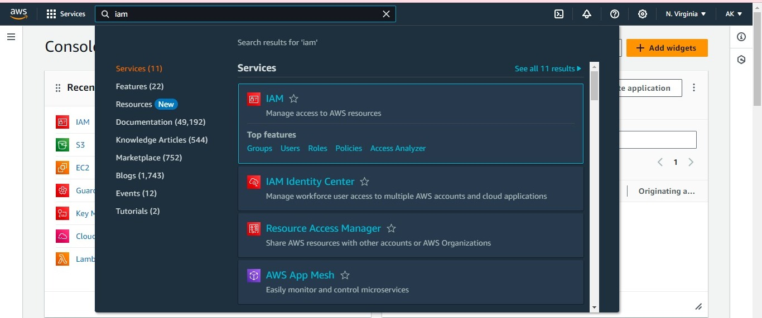

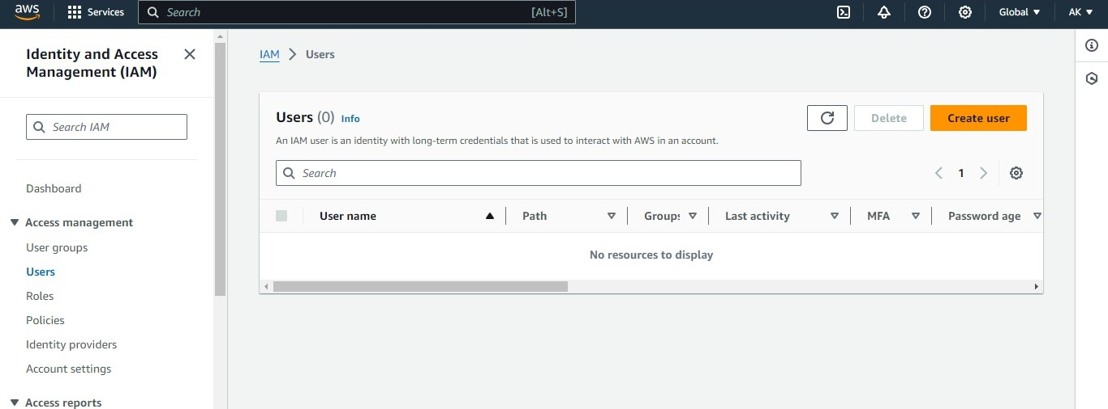

* My first user name is “DevOpsEngineer” and attach the poicies according to the user specifications.

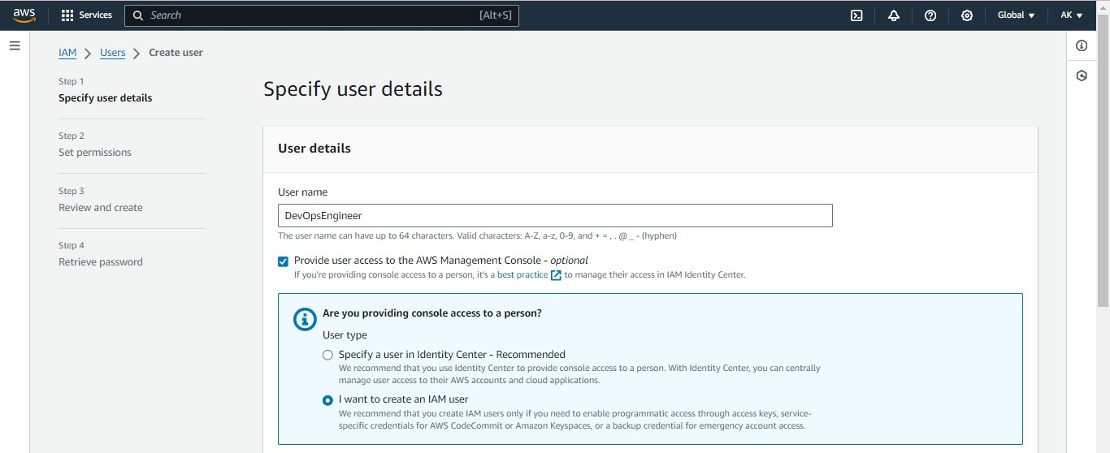

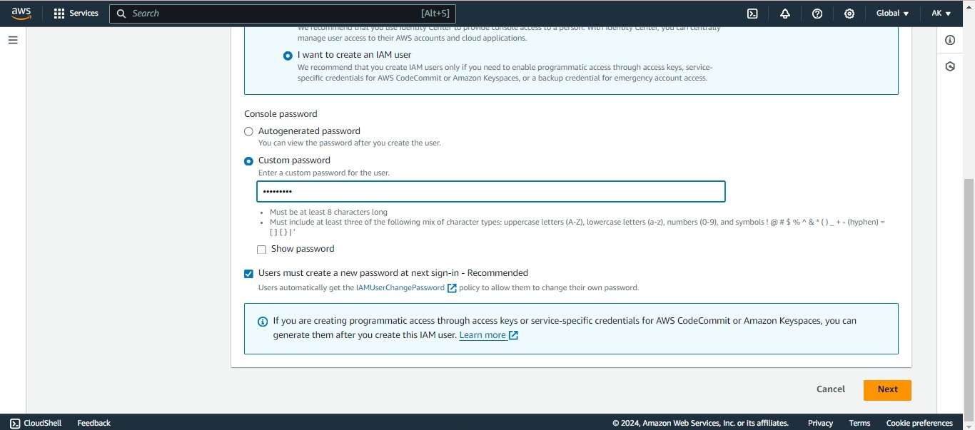

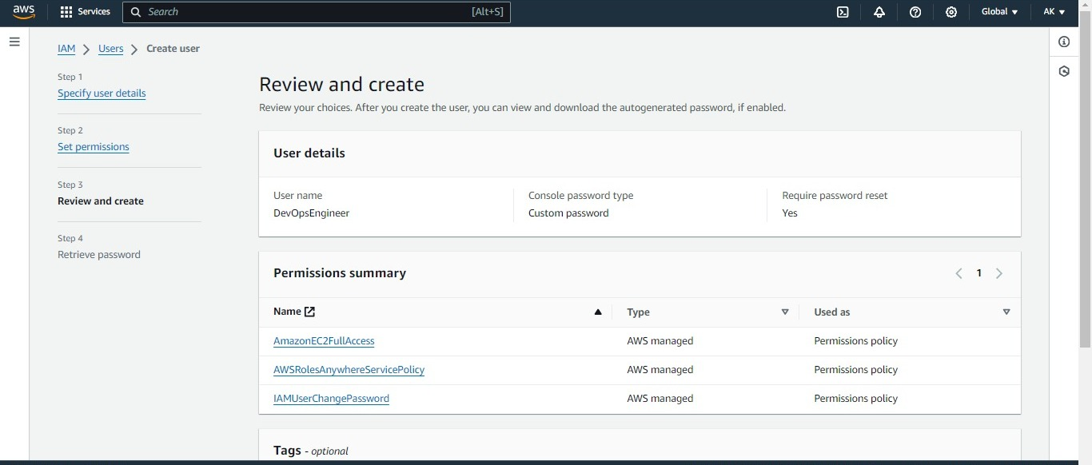

* Second user name is ”Data_Analyst”.

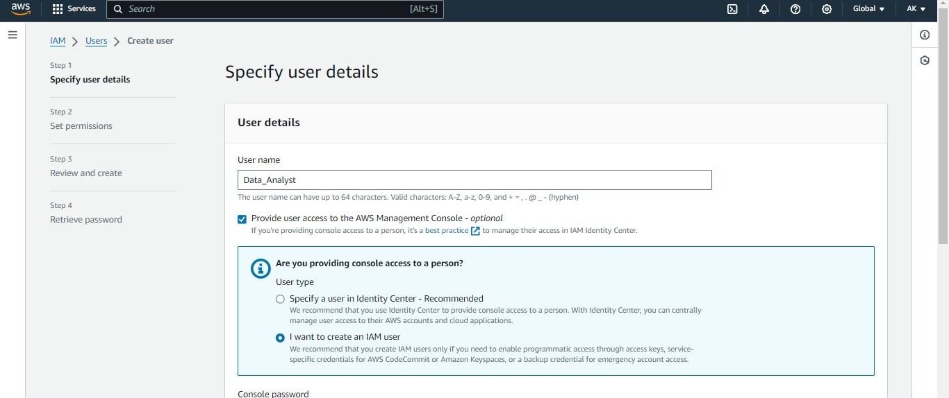

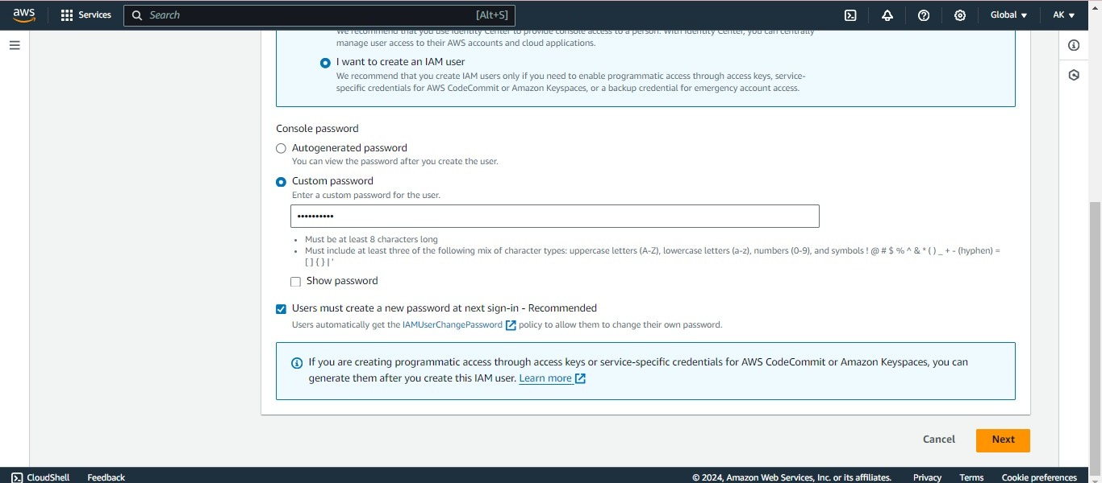

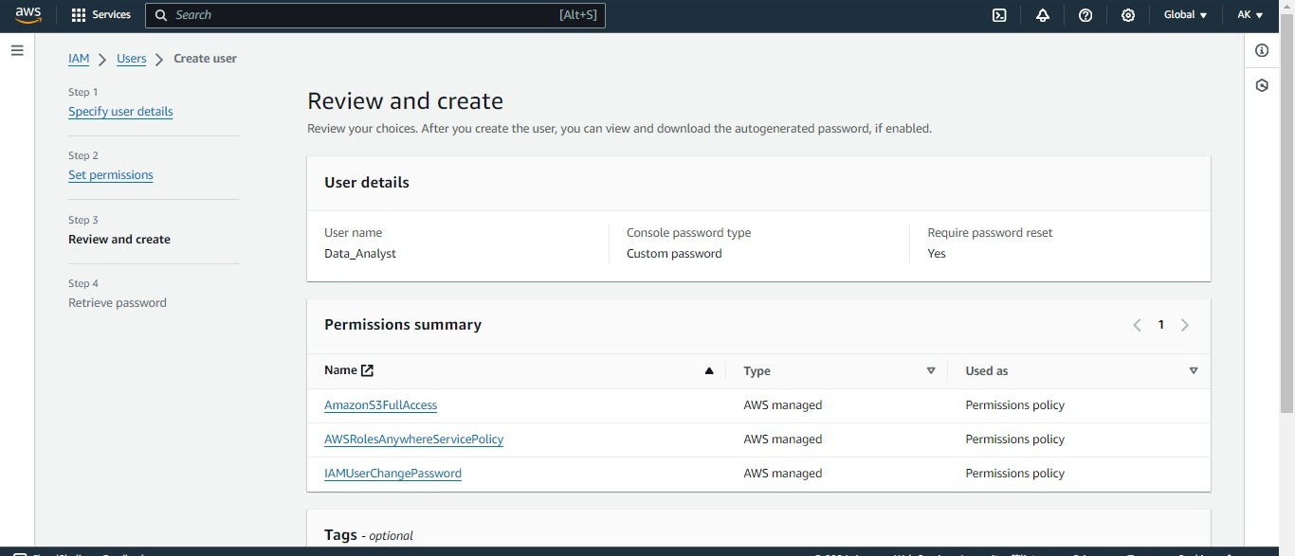

* Save or dowload the user names and passwords.

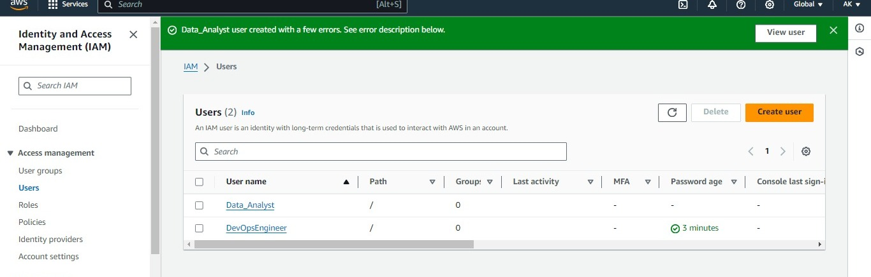

* By using the user name and password log in to the AWS console through IAM user.

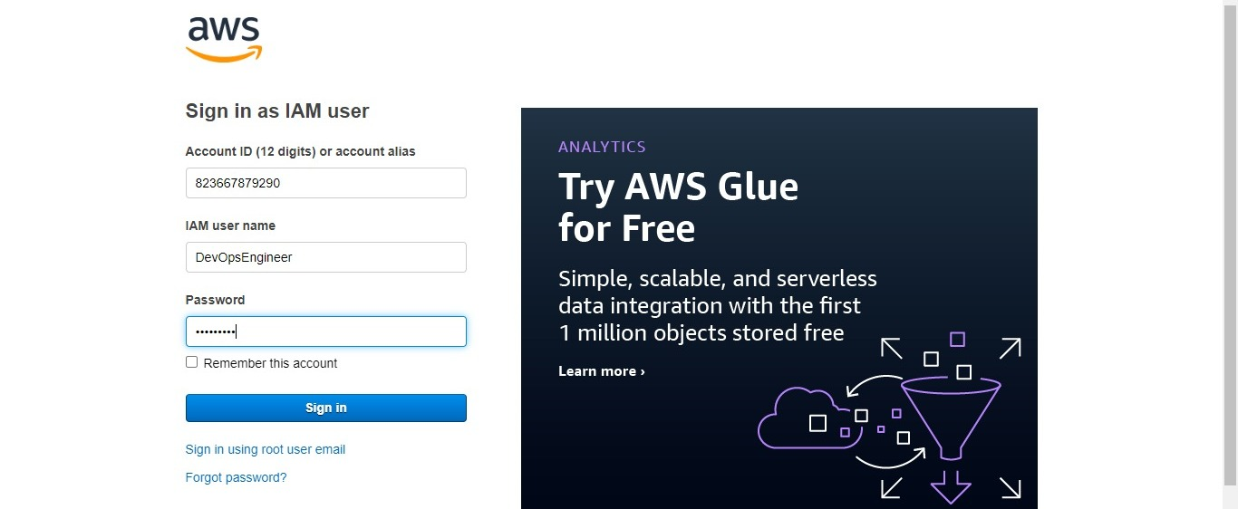

* After logging in, it will ask to change the password.

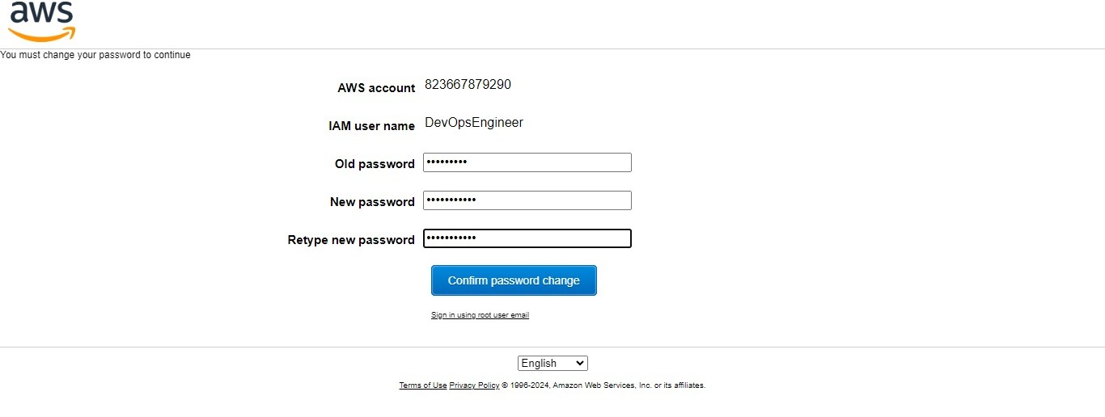

* Now assign the roles to the users in the following way.
* Again go to IAM 🡪 Roles 🡪 create role.
* In that select AWS account, permission policies.
* At the top right corner we can see the user name along with my account.

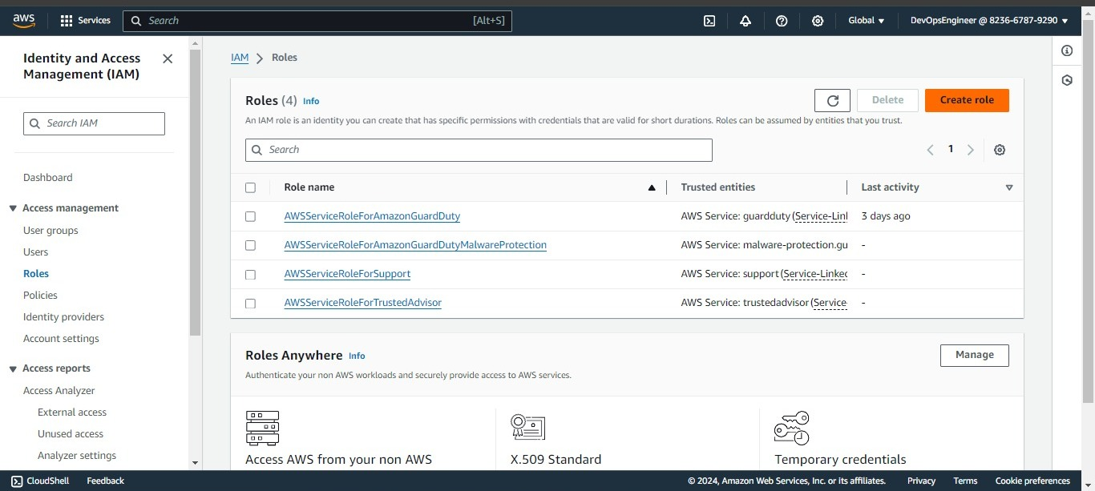

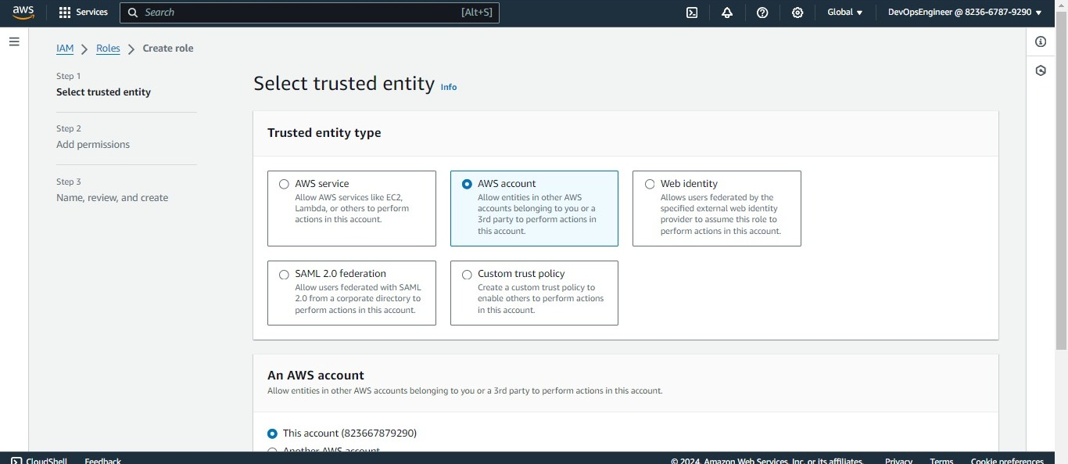

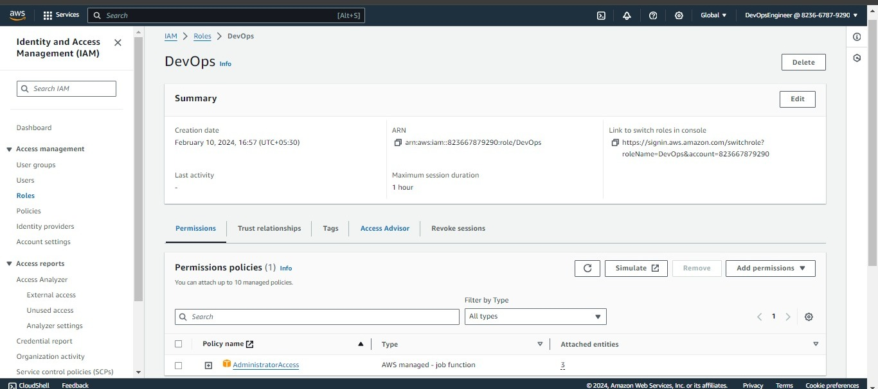

* Repeat the same process, which I did for the user 1.

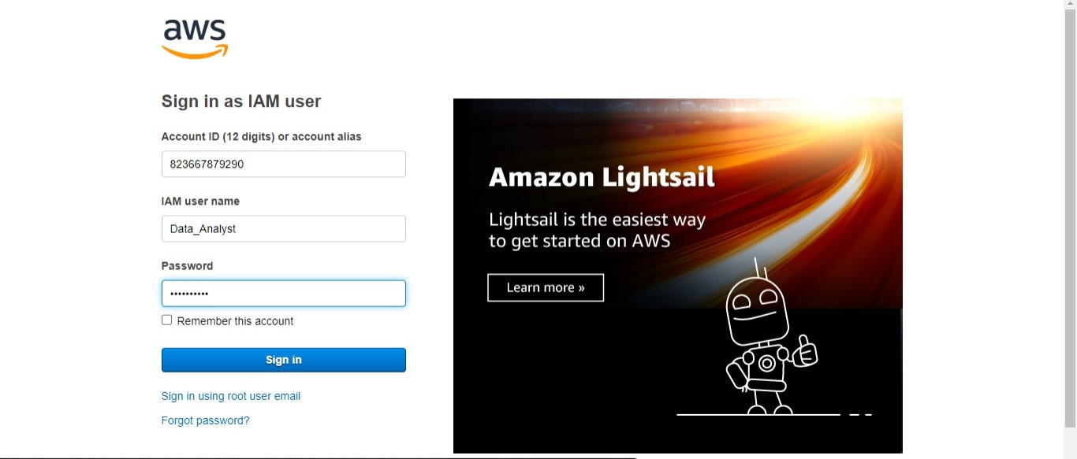

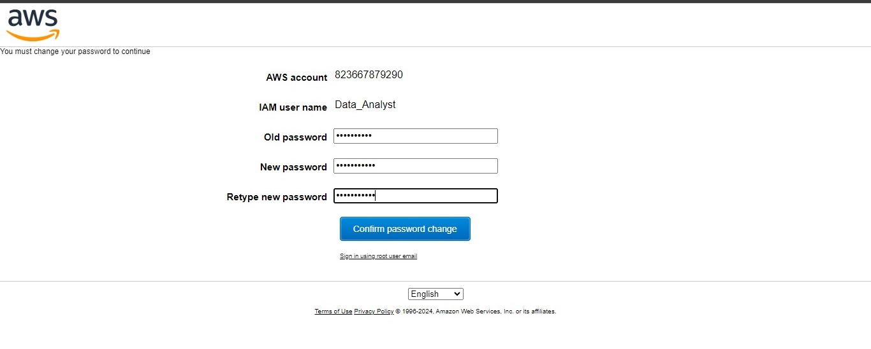

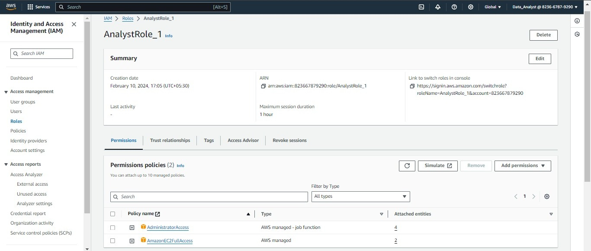

* Finally, role are assigned to the specific user.

